Provider Configuration
Single provider multiple configuration:
Till now, we have been hardcoding the aws-region parameter within the providers.tf. This means that resources would be created in the region specified in the providers.tf file.
Use cases:
- Let’s assume we need to create an ec2 instance in us-east-1 and we need to create another ec2 instance in ap-south-1.
- Let’s assume we need to deploy an ec2 instance Account01 and we need to create an ec2 instance in another Account2.
How ever we can add only one provider. This can be overcome by using alias variable.
Let’s assume you want to create 2 elastic IPs in 2 different regions. We have to define like this.
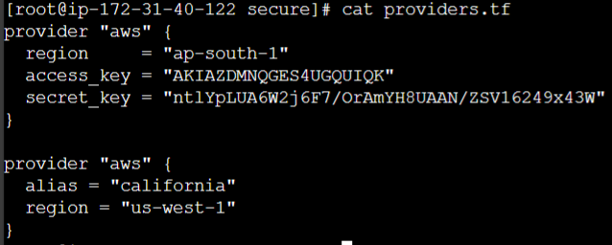
Note: From above scipt, we need not to define ‘alias’ for the first region. ‘Alias’ value can be anything that is upto us. We need to define those values like below.
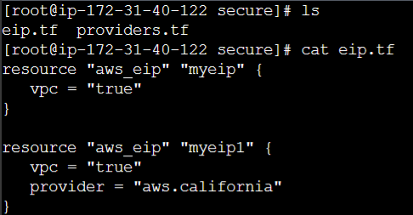
We need to define the ‘provider’ in the config script. In ‘provider’ the ‘aws’ will provider name and ‘california’ will be alias.
Use case2:
How to create 2 instances in 2 different accounts?
For that first we need to configure the credentials of account 2 like this.
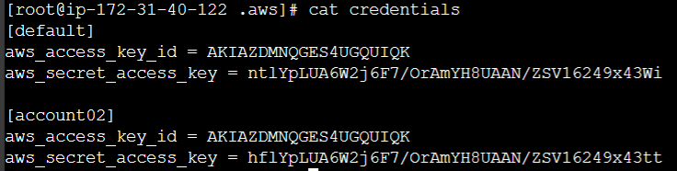
We need config above values in providers.tf file.
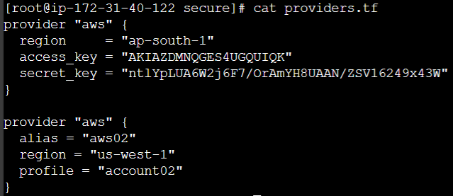
Here we will only give ‘account02’ credentials not the ‘default’ credentials and the configuration script will look like this.
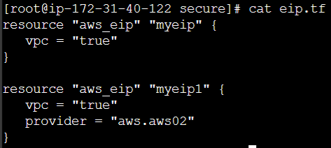
With this it will create the ec2 instance in both the accounts.
Terraform & Assume Role with AWS STS
It’s hard to explain here, please watch the video ‘100.Terraform & Assume Role with AWS STS’.
Sensitive Parameter

With organization managing their entire infrastructure in terraform, it is likely that you will see some sensitive information embedded in the code.
When working with a field that contains information likely to be considered sensitive, it is best to set the Sensitive property on its schema to true.

Eg:
Locals {
db_password = {
admin = “password”
}
}
output “db_password” {
value = aws_db_instance.db.password
description = “The password for logging in to the database”
sensitive = true
}
If you mention the sensitive to “true” it will prevent the field’s values from showing up in CLI output and in TF cloud.
It will not encrypt or obscure the value in the state.
HashiCorp Vault
HashiCorp Vault allows organizations to securely store secrets like tokens, passwords, certificates along with access management for protecting secrets.
One of the common challenges nowadays in an organization is “secret Management”
Secrets can include, database passwords, AWS access/secret keys, API Tokens, encryption keys and others.
The Vault will generate the key of any service like database,AWS,Linux etc and provide to the user. So password will be in rotational way If password generates today again that password will expire in 24 hrs it will generate a new one.
Watch the video for more understanding.
The vault provider allows TF to read from, write to, and configure Hashicorp vault.
Since it’s unable to document, pls watch the video.
Dependency lock file
We are going to discuss about this Terraform.lock.hcl
Provider plugins and TF are managed independently and have different release cycle.
Aws plugin v1 Terraformv1.2
AWS Plugin v2
AWS Plugin v3
We need to understand that release cycle of both TF and the provider plugins are independent of each other.
Challenges:
The AWS code written in TF is working perfectly well with AWS plugin v1. It can happen that same code might have some issues with newer AWS plugins.
Version Dependencies:
Version constraints within the configuration itself determine which versions of dependencies are potentially compatible
After selecting a specific version of each dependency TF remembers that decision it made in a dependency lock file so that it can (by default) make the same decisions again in future.
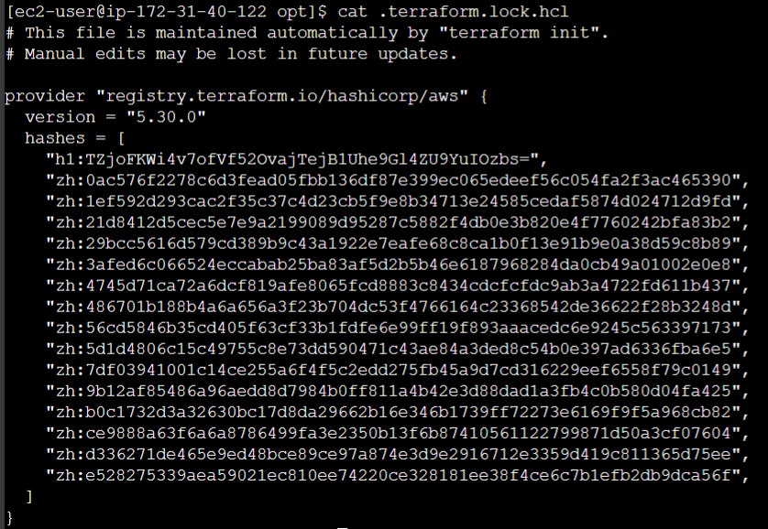
If you see the version it is the latest version. If you give the older version in configuration file that is if your TF wants in a build older version that 4.5,5.0 etc. it won’t be replaced with 4.5 or 5.0 It will sho the error . To change the version to older version we need to run the command after configuring the version in configuration file.
Upgrading option:
If there is requirement to use newer or downgrade a provider, can override that behaviour by adding the ‘-upgrade’ option when you run ‘terraform init’, in which case terraform will disregard the existing selections.
terraform init -upgrade
Note: When installing a particular for the first time, TF will pre-populate the hashes value with any checksums that are covered by the provider developer’s cryptographic signature, which usually covers all of the available packages for that provider version across all supported platforms.
At present, the dependency lock file tracks only provide dependencies.
TF does not remember version selections for remote modules, and so TF will always slect the newest available module version that meets the specified version constraints.

